Defining classes Lab: part 1 and part 2 - answers

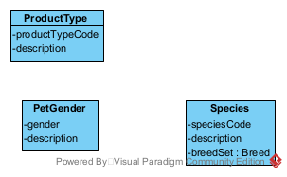

Create a Product Type

|  |  |  |  |
| --- | --- | --- | --- |
| Use Case Name | Create a product type | | |
| Triggering Event | A new type of product on the market | | |
| Brief Description | Allows the Owner to create a product type | | |
| Actors | Owner | | |
| Related Use Cases |  | | |
| Preconditions | Owner has opened the Main Menu. | | |
| Post Conditions | Product type is added and available to query | | |
| Flow of activities | Actor | | System |
|  |  | Requests to add a new product type | Displays a list of product types and prompts for product type and product type description. |
|  |  | Enters product type and description | Verifies that product type and description have been entered.  Prompts for confirmation |
|  |  | Confirms entry | Saves the product type and returns to the main menu |
| Exception Conditions | * Owner chooses to cancel adding the product type | | |

Change Product Type

Delete Product type

Create Pet Gender

Change Pet Gender

Delete Pet Gender

Create a Species

Change a Species

Delete Species

